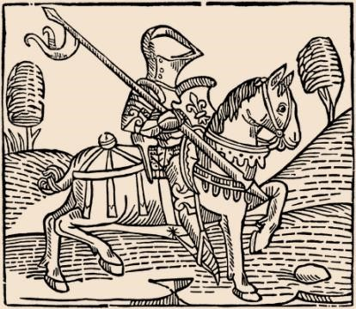
Knights

The path to knighthood began at the age
of seven, when a
vassal sent his son to the
lord’
s house to become a page. For
the
next
seven years
,

a page was cared for by
the women of the house, who ins
tructed
him in courtesy, cleanliness, and religion.

At 14 the page became a squire, a
personal attendant to a knight. From the
knight he learned riding and all the skills
of war, as well as hunting, hawking, and
other sports.

The Knightly Code

When he w
as judged ready (generally
between the ages of 18 and 21) the squire
was knighted in a religious ceremony
after spending the night guarding his
armour before a church altar. He had to
swear to the kn
ightly code which asked
him to “
protect the weak, defencel
ess, and
helpless, and fight for the general welfare of all.” This code was rarely lived up to, but it remained the standard for chivalry and proper behaviour amongst the nobility for centuries.

Fighting
Battles were usually small affairs, fought between the knights of individual lords. The object in a fight wasn't necessarily to kill an opponent, but to capture and ransom him. Your foe was worth more to you alive than dead.

Tournaments
Imported from France in the 12th century, tournaments were an essential part of military and social life. These “war games” consisted of individual contests (jousts), and group combat. Lances and swords were blunted, but tournaments were a place where reputations were made, so the fighting was hard and dangerous. Prizes were given to the winners, and some knights, such as the famous William Marshall, made their fortunes on the tournament circuit, much as a modern rodeo rider might in the American West. The armour worn in tourneys was different from regular battle gear. It was padded inside, very heavy and awkward to move in. This made it extremely cumbersome for knights.

The object of the tournament was simply to unhorse your opponent, though often the fighting was so fierce that men were killed. Challengers erected tents at one end of the ground and hung a shield outside. A knight accepting the challenge rode up and touched his lance to the shield. The winner of the jousts was awarded a prize by the Queen of Beauty, elected for the occasion from amongst the women present. By the 14th century tournaments became rousing fairs complete with singing, dancing, and feasting which might last for several days.

Eventually, the invention of gunpowder and artillery greatly contributed to the decline of knights as soldiers. However, their imagery and spirit has lived on to this day.

Name: ____________
______

- What did a page learn and why do you think this was important for a knight?

- What was a boy called during the second stage of training and what did he learn during this this stage?

- In the third paragraph, it is stated that, “the code was rarely lived up to.” What do you think the author meant by this?

- At what age would a boy become a knight? Do you feel this is an appropriate age? Explain.

- What is the best definition of “cumbersome” in the 5th paragraph?

- To what modern day American event might the medieval tournaments be compared?

- In the space below, create an advertisement for a medieval knight tournament. Be sure to include visuals that show what attendees can expect to see as well as slogans and descriptions of what will occur.

Name: ___
Answer Key
______

- What did a page learn and why do you think this was important for a knight?

A page learned courtesy, cleanliness, and religion from the women of the house. Students’ asnwers about why they feel this was important will vary.

- What was a boy called during the second stage of training and what did he learn during this this stage?

After being a page, a boy would become a squire, or personal attendant to a knight. From the knight he learned riding and all the skills of war, as well as hunting, hawking, and other sports.

- In the third paragraph, it is stated that, “the code was rarely lived up to.” What do you think the author meant by this?

Open to student interpretation, but they should infer that most knights did not protect the weak and defenseless but instead did the bidding of his lord.

- At what age would a boy become a knight? Do you feel this is an appropriate age? Explain.

A boy became a knight usually between the ages of 18 and 21. Student responses about this age will vary. They will likely believe that it is an appropriate age considering this is when students in our society graduate from college and enter the workforce.

- What is the best definition of “cumbersome” in the 5th paragraph?

Based off of the description of armor as heavy and awkward to move in, students should be able to infer that cumbersome means bulky, burdensome, or hard to handle.

- To what modern day American event might the medieval tournaments be compared?

Open to student opinion, but they could be compared to the Olympics, athletic meets, bull fighting tournaments, or many other modern events.

- In the space below, create an advertisement for a medieval knight tournament. Be sure to include visuals that show what attendees can expect to see as well as slogans and descriptions of what will occur.

Open to many different student designs and creations.

© Students of History - http://www.teacherspayteachers.com/Store/Students-Of-History

